**SKILLS TEST 5 (Electromagnetics) NAME: SOLUTIONS**

*(22 Marks, 22 Minutes)*

1. As a square loop 25cm $×$ 25cm of wire weighing 5 grams is dropped into a uniform magnetic field of 0.5 T from an area of no magnetic field it moves at a constant speed of 1ms-1.

a) Mark in the direction of current flow

b) Calculate the emf induced as the wire moves from completely out of to completely in the field.

Emf=

*✓*

*✓*

*(2 Marks)*

b) Calculate the emf induced as the loop moves within the field.

*0V ✓*

*(1 Mark)*

c) What is magnitude of the magnetic force on the loop as it enters the field?

*✓*

*✓*

*(2 Marks)*

2. Determine the direction of current in each of the following situations (add arrows).

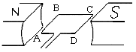 a. Motor – side AB turns downwards b. Generator – side CD turns downwards

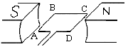

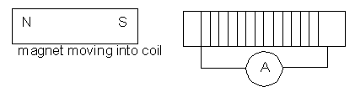 c.

*(3 Marks)*

3. A generator has slip rings. Sketch a graph of emf vs time starting with the coil parallel to the magnetic field.

emf

*(3 Marks)*

*time*

Sine curve *✓*

AC *✓*

Start at max or min *✓*

4.A coil of 120 turns is 10.0 cm in diameter and has its plane perpendicular to a magnetic field of flux density 0.050 Tesla which is produced by permanent magnets. The coil rotates at 50 Hz (50 rotations per second)

a) What is the magnitude of the change in flux when the coil rotates through 90º as shown.

COIL POSITION:

S

N

S

N

moves to

*✓*

= 1.96 *✓*

*(2 Marks)*

b) What is the emf induced when this happens?

*✓*

*(3 Marks)*

5.

A wire 60 cm long moves through a magnetic field of strength 0.3T at a velocity of 15 ms-1, as shown in the diagram: ● ● ● ●

a) Indicate on the diagram which end is positive.

(1 Mark)

● ● ● ●

● ● ● ●

● ● ● ●

● ● ● ●

+ve *✓*

b) What is the magnitude of the emf induced in the wire?

$Emf= \frac{-BA}{∆t}=\frac{-0.3\left(0.6×15\right) }{1}=-2.7V$

(2 Marks)

6. Draw in the magnetic field on these arrangements:

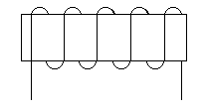

*i*

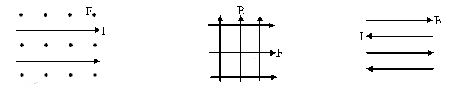

 

*3(3 (3 Marks)*